**Topic**

Statement of Purpose

**Backgrounds**

I’m about to attend the exchange program to Japan in September this year. However, I assume I’ve finished the program and graduated from NTU, about to apply for MS degree in The University of Tokyo. (Also, the program I decided to attend seems don’t have to write SoP and don't have past data that can be refered. It’s only need to write Statement of study plan. So, I found the past SoP question of Kyoto University, and change all “Kyoto University” to “UTokyo”)

Link for Sop sample of Kyoto University: <https://www.kyoto-u.ac.jp/zh-tw/education-campus/international/students1/aao>

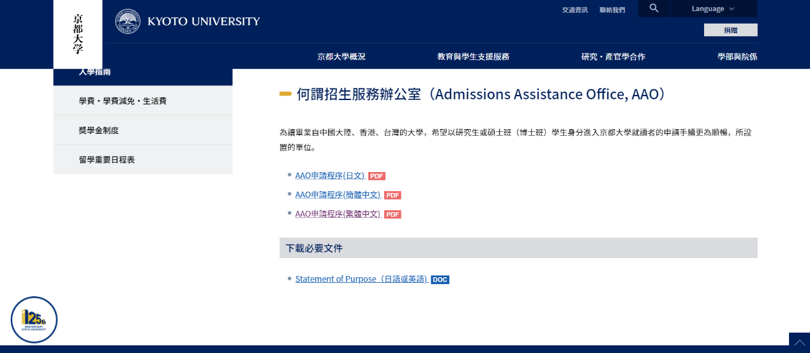

Original Sop question(for Kyoto University):

1) personal statement

2) your motivation for applying for your prospective supervisor or graduate study at Kyoto University

3) your past research /study

4) your research proposal at Kyoto University

5) your future career plans

Sop question for UTokyo:

1) personal statement

2) your motivation for applying for your prospective supervisor or graduate study at UTokyo

3) your past research /study

4) your research proposal at UTokyo

5) your future career plans

**Statement of Purpose for Mechanical Engineering Master Program**

**in the University of Tokyo (UTokyo)**

I’m Aaron Chou, a student who graduated from National Taiwan University (NTU), Department of Mechanical Engineering (ME). I have also been an exchange student at Aoyama Gakuin University (Sagamihara Campus) in Japan, Kanagawa a semester. I aim to innovate aerial robots and influence Taiwanese people to keep pace with world-class engineering experts.

The school motto of UTokyo says, “Aim for excellence.” I believe the program at UTokyo fully aligns with my goal and value because it is one of the leading institutes in Asia. Backtracking to my childhood, when I was in junior school, I was only interested in mathematics and became fascinated with physics and earth science in high school. Finally, I got a high grade on the university entrance examination and entered the best comprehensive university in my country.

Actually, the choice of the ME department was because the test score achieved the enrollment standard since I didn't have any extra interests in high school except learning. After I studied the Mechanism taught by Prof. Kuan-Lun Hsu, it enlightened my understanding of robot joints and my interest in kinematics. Later, I learned another course where students needed to make a billiard car with a group. I will never forget the time I used the joystick to practice our car until 4 am before the examination. It was my first time discovering the charm of ME.

I had the idea of studying abroad since high school because a teacher encouraged us to explore the world. From attending the best local high school to the best university in the country, I want to step out of my comfort zone and move toward another milestone. An old Chinese saying goes, "There are always people better than you." During my time at NTU, I have deeply realized this truth. Therefore, I become humble but never be content with the status quo.

As mentioned before, I want to innovate on aerial machines. Since I discovered the aerial robot DRAGON developed by the laboratory of Prof. Zhao Moju, an assistant professor in the Department of ME of the UTokyo, I chose UTokyo to achieve my goal. I never thought that an aerial robot could transform without touching the ground and accomplish tasks like traversing complex terrain. This technology is currently only developed by UTokyo, but it's still not feasible in real life. Therefore, I want to optimize this machine to amaze the world.

One of the most relevant projects I've engaged in is a drone competition. Our group started from zero, but we created drones and built a practice area. I was responsible for designing and building the practice field. The most exciting fact is that we are only four students, and with two months of hard work day and night, we entered the final and won the championship. After this competition, I gained many experiences, such as perfect teamwork with team members and making good use of time, allowing us to complete these impossible tasks. I also expect infinite possibilities in aerial robots and am ready to devote myself to this field.

As for the research proposal, I aim to investigate and develop control methods for the DRAGON. I wish to implement Robotic Operating System (ROS) on the robot. I learned ROS from Prof. Li-Chen Fu, a well-known expert in robotics. ROS offers a software platform from research and prototyping to presentation. With diverse open-source development kits for ME applications, ROS is a suitable operating system architecture for complex machines.

My final goal is to impact the engineering field in Taiwan. In our country, high school students don't learn engineering theory, but when I was a high school team mentor, I helped school students to build robots that could perform complex tasks such as shooting and hanging. The team has only three years of experience. Although we suffered a two-year epidemic in the middle, we're lucky to participate in the First Robotics Competition's world finals in the United States. Therefore, I was able to exchange with the world's top students, deepening my belief in culturing more engineering talents in Taiwan. I want to work in a company such as JAXA or NASA for tasks related to aviation and ME in the future. Moreover, I hope to have a sideline about engineering education through Youtube or other platforms to make more people in Taiwan interested in ME.